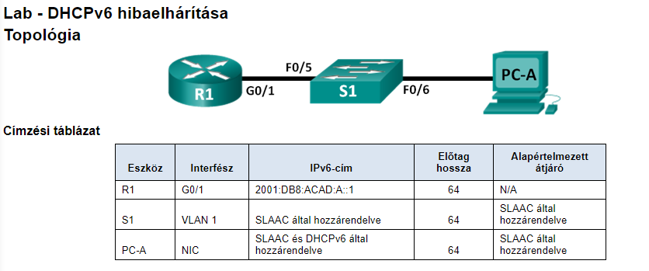

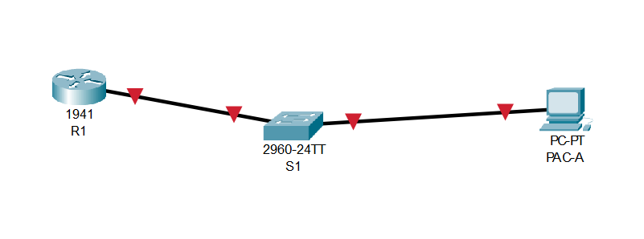

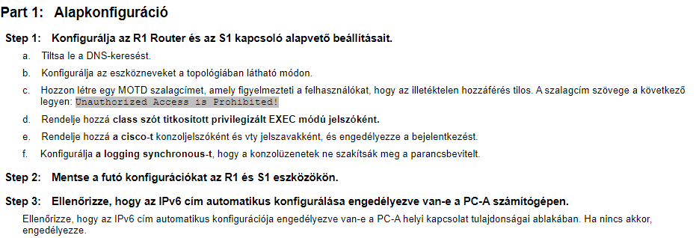

Part1.1:

R1:

enable

conf t

no ip domain-lookup

hostname R1

banner motd "Unauthorized Access is Prohibited!"

enable secret class

line vty 0 15

password cisco

login

exit

line con 0

password cisco

login

logging syn

S1:

enable

conf t

no ip domain-lookup

hostname S1

banner motd "Unauthorized Access is Prohibited!"

enable secret class

line vty 0 15

password cisco

login

exit

line con 0

password cisco

login

logging syn

1.2:

R1:

end

copy running-config startup-config

S1:

end

copy running-config startup-config

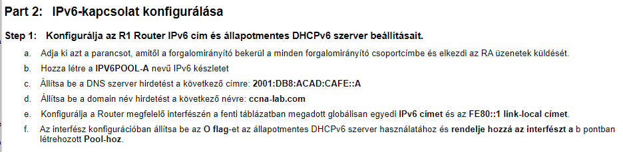

Part2:

R1:

conf t

ipv6 unicast-routing

ipv6 dhcp pool IPV6POOL-A

dns-server 2001:DB8:ACAD:CAFE::A

domain-name ccna-lab.com

exit

int g0/1

ipv6 address 2001:DB8:ACAD:A::1/64

ipv6 address FE80::1 link-local

ipv6 nd other-config-flag

ipv6 dhcp server IPV6POOL-A

no sh

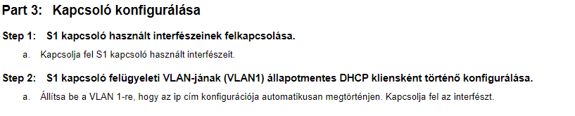

Part3:

S1:

conf t

interface range fastEthernet 0/5-6

no sh

exit

int vlan 1

ipv6 address autoconfig

no sh

